Sample
Snagging Report Saturday, 24 September 2022
Prepared For Anon

95 Defect Defects Identified

Ian Lively MRPSA (Former CEnv FCIOB MCABE MAPM) Lively Professional Services Ltd



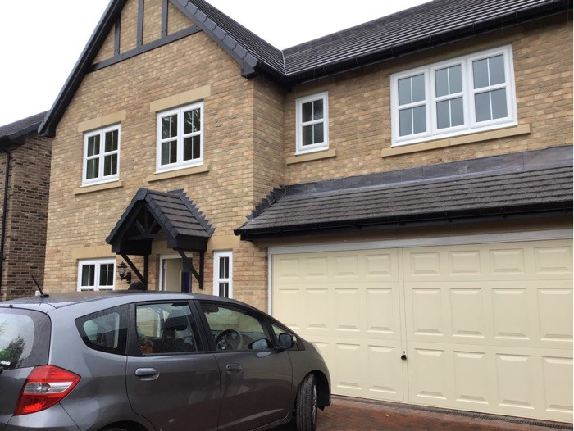
Location 1 Sample
Assigned To Identification Summary

Overall the house has been finished to a good standard throughout however with a little more attention to detail the majority of issues highlighted within the report could have been avoided.
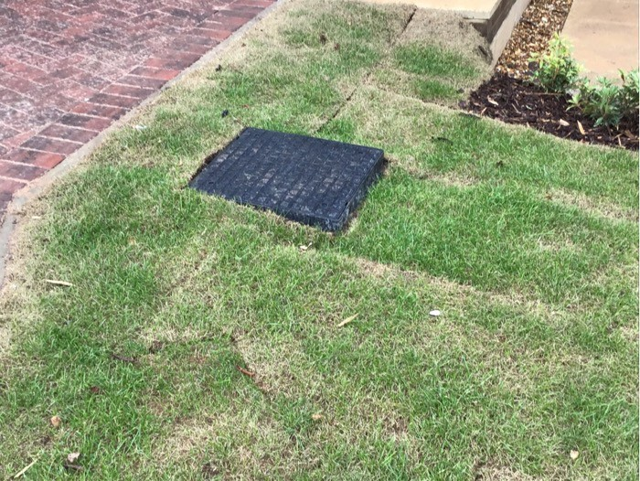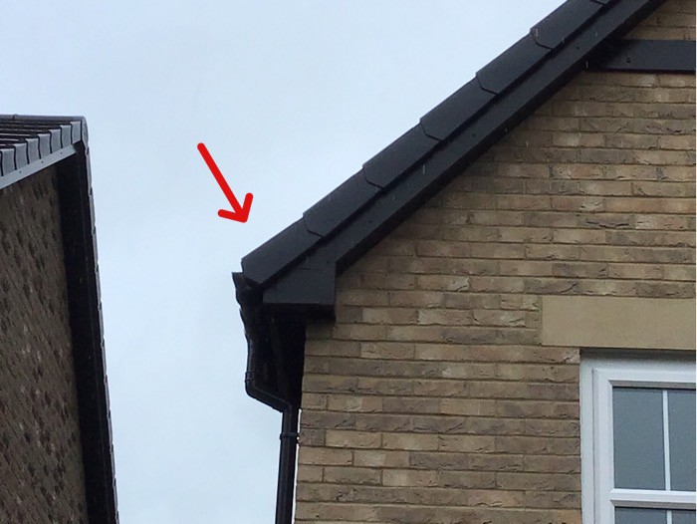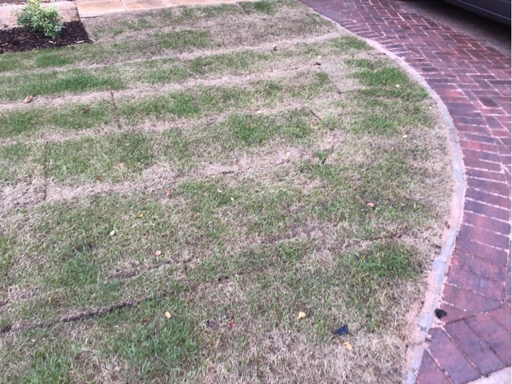
Location 2 Front Elevation
Assigned To Groundworker
The manhole needs lowering and the screws fitting in the lid.
Location 3 Roof
Assigned To Roofer
The bottom dry verges need mechanically fixing to comply with BS5534
Location 4 Front Elevation
Assigned To Builder
The turf needs monitoring to see if it comes back or replace.

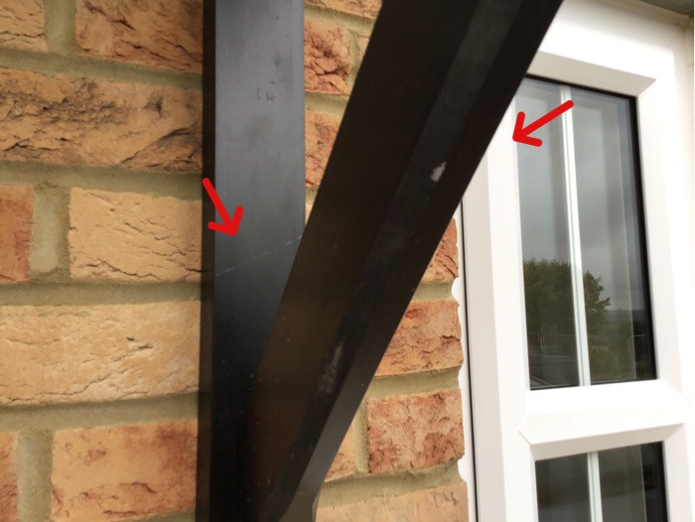
Location 5 Front Elevation
Assigned To Plastic Surgeon
The front canopy and gallows brackets are marked
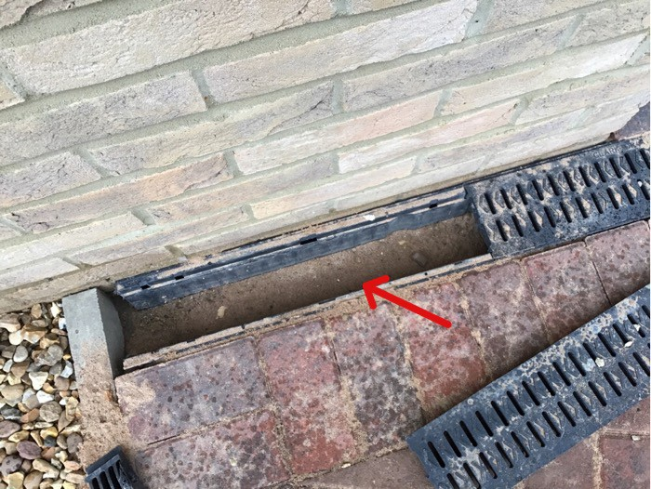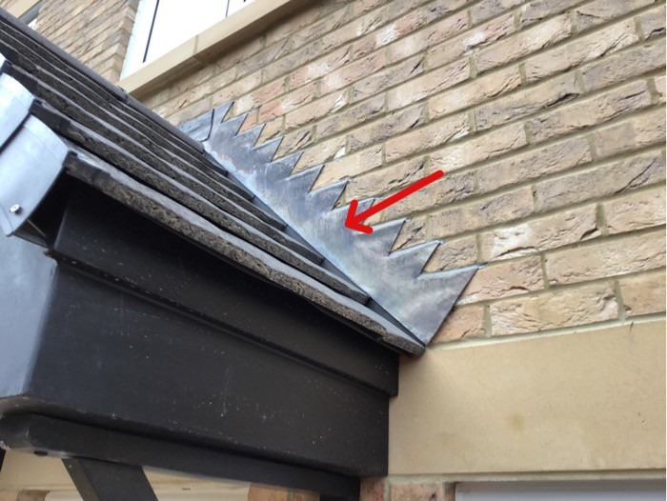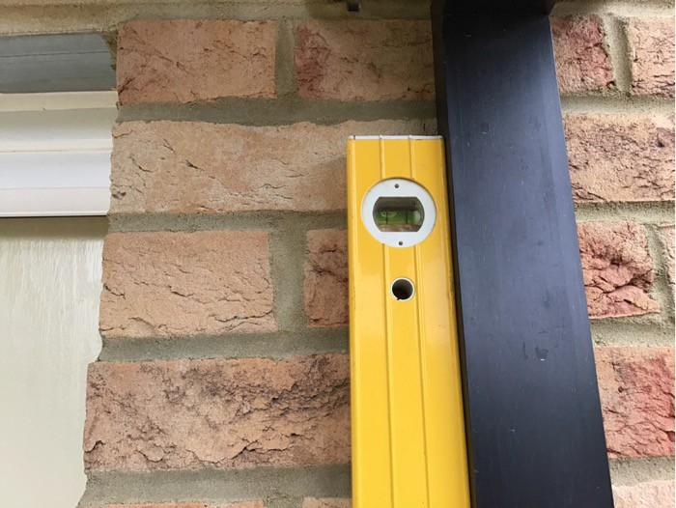
Location 6 Front Elevation
Assigned To Groundworker The aco drain needs cleaning.
Location 7 Front Elevatio
Assigned To Roofer
The lead flashing needs patinating.
Location 8 Front Elevation
Assigned To Joiner
The right hand gallows bracket is not plumb.

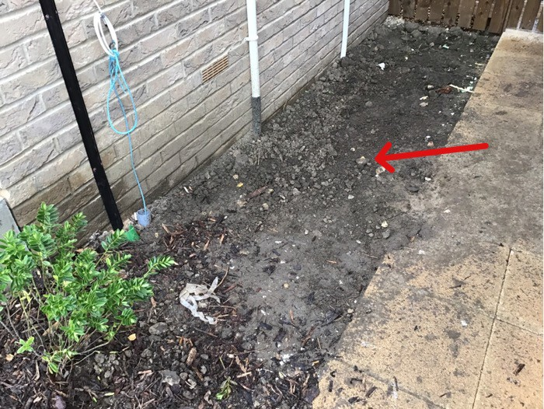
Location 9 Right Hand Elevation
Assigned To Landscaper
The landscaping needs finishing
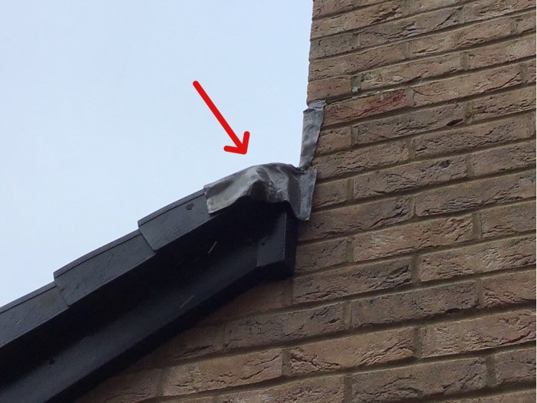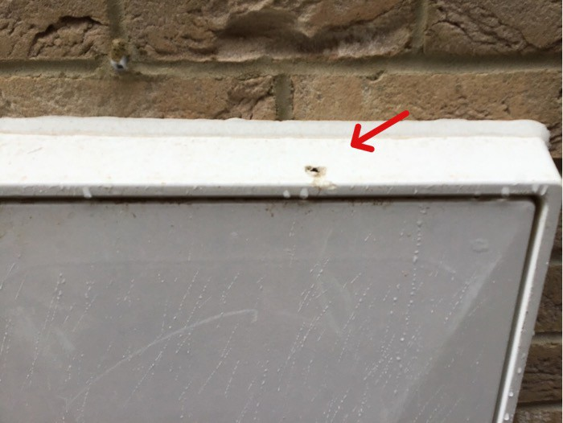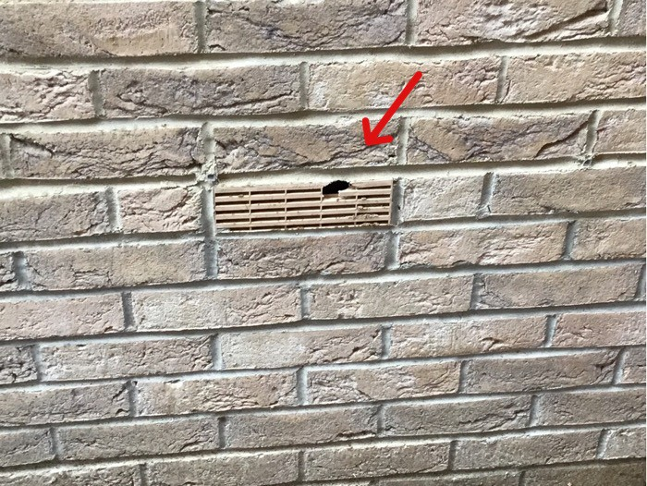
Location 10 Right Hand Elevation
Assigned To Roofer
The flashing needs redressing
Location 11 Right Hand Elevation
Assigned To Plastic Surgeon The electric box is damaged
Location 12 Right Hand Elevation
Assigned To Groundworker The air brick is damaged.

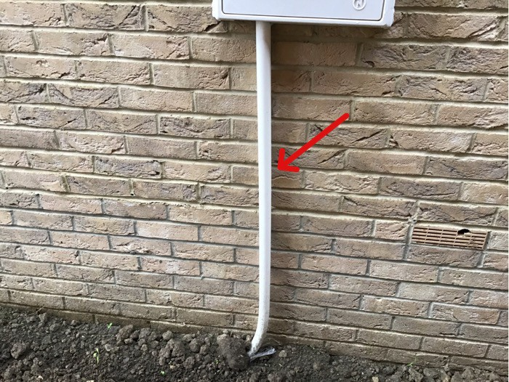
Location 13 Right Hand Elevation
Assigned To Groundworker
The electric hockey stick needs a clip
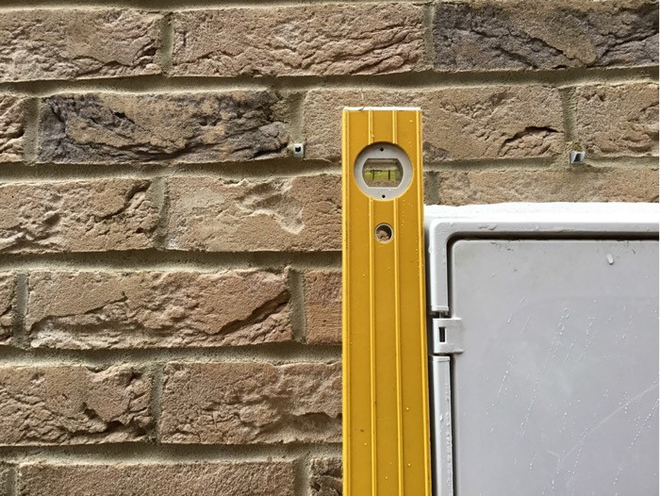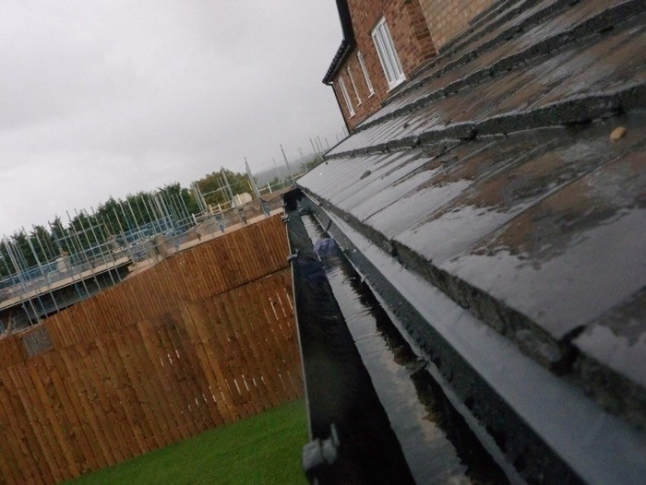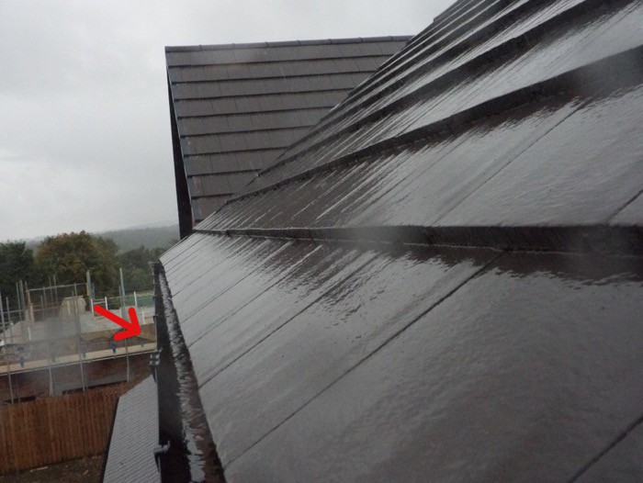
Location 14 Right Hand Elevation
Assigned To Bricklayer
The electric box is no plumb.
Location 15 Rear Elevation
Assigned To Plumber
The low level gutter is holding water suggesting incorrect falls.
Location 16 Rear Elevation
Assigned To Plumber
The gutter is holding water suggesting incorrect falls.

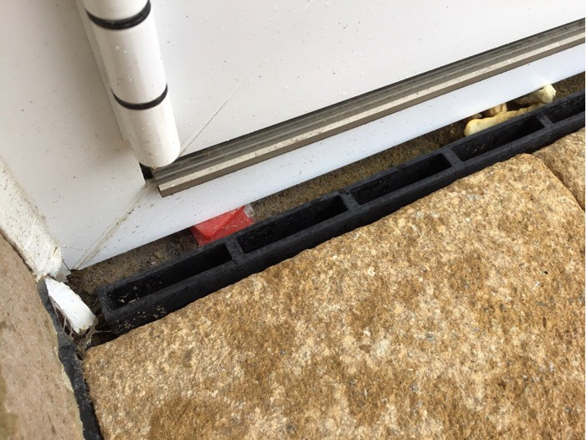
Location 17 Rear Elevation
Assigned To Mastic
Underneath the bifold doors have not been sealed.
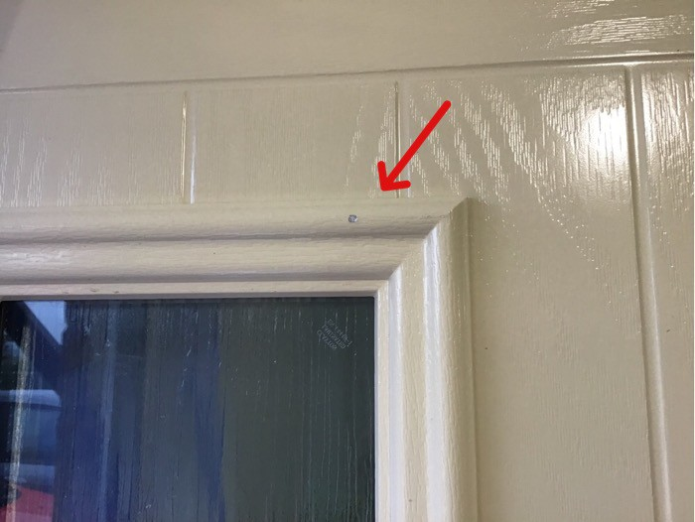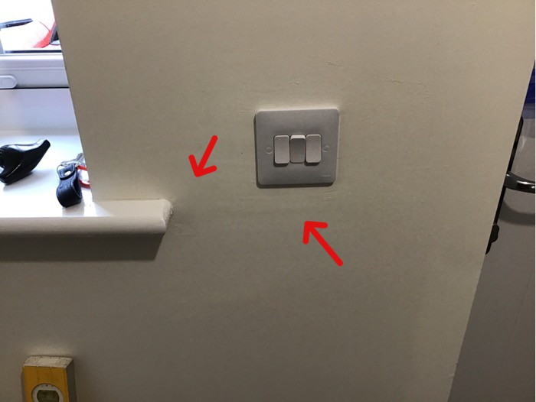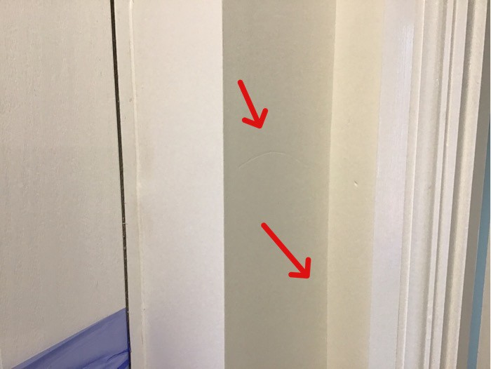
Location 18 Hall
Assigned To Plastic Surgeon
The front door glazing bead is chipped.
Location 19 Hall
Assigned To Decorator The wall needs filling.
Location 20 Hall
Assigned To Decorator
The wall needs. Filling to the right of the front door.

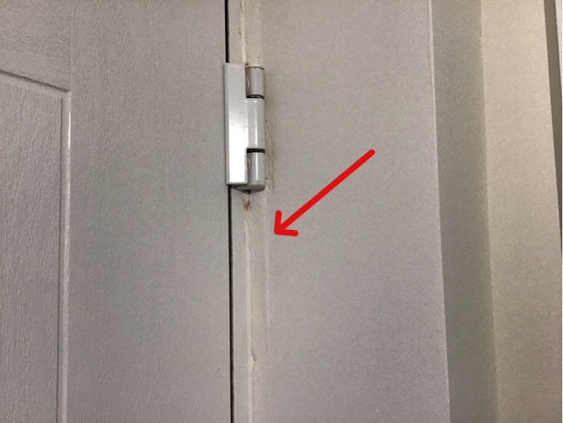
Location 21 Hall
Assigned To Decorator
The right hand front door reveal needs filling.
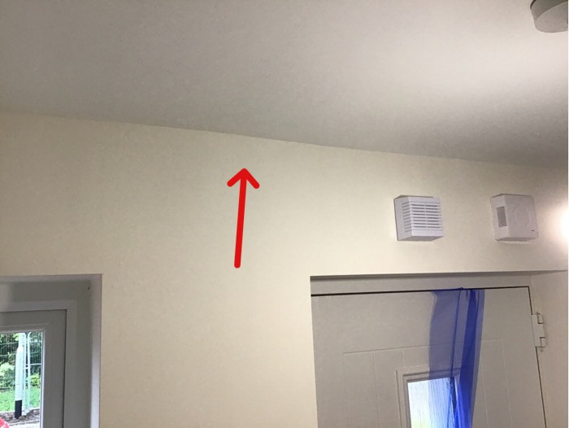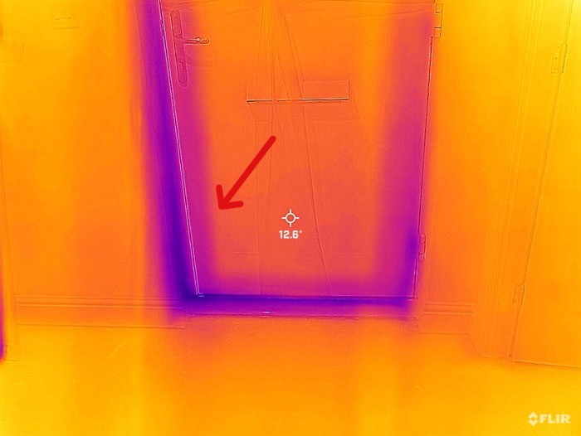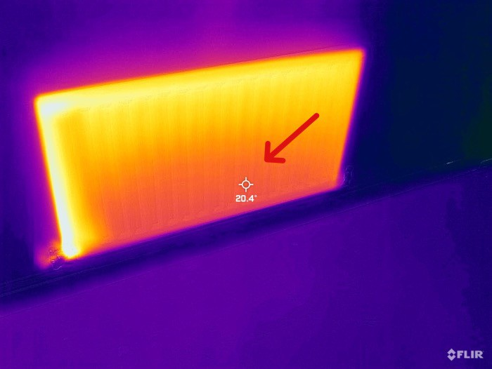
Location 22 Hall
Assigned To Plasterer
The ceiling above the front door is out of tolerance.
NHBC Standards Chapter 9.1.3
Location 23 Hall
Assigned To Joiner
The front door needs tightening on the seals to prevent cold air ingress.
Location 24 Hall
Assigned To Plumber
The radiator needs balancing.

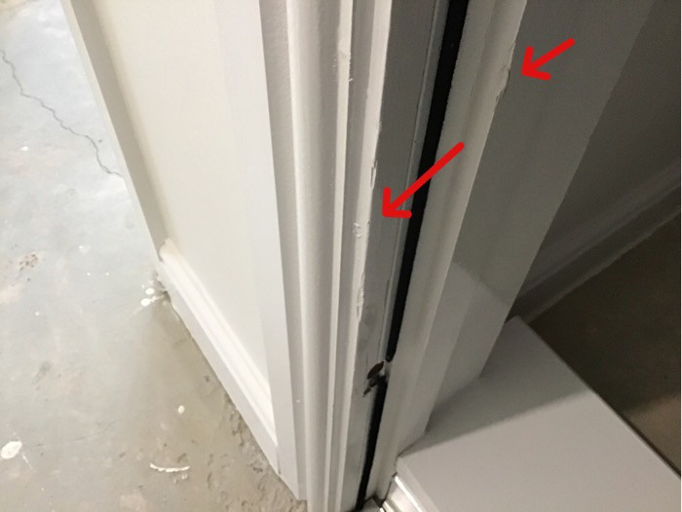
Location 25 Hall
Assigned To Decorator
The garage door needs filling in several places.
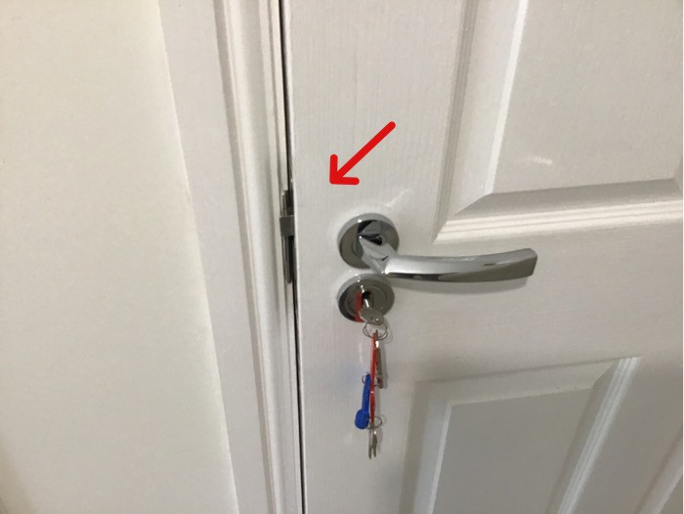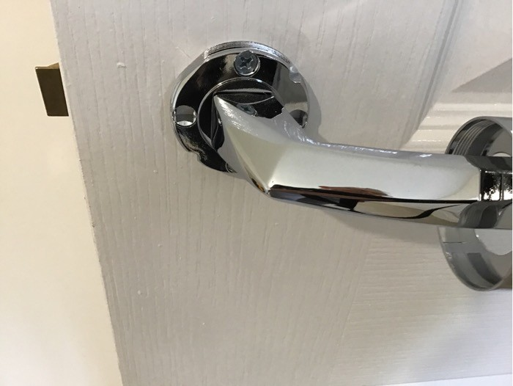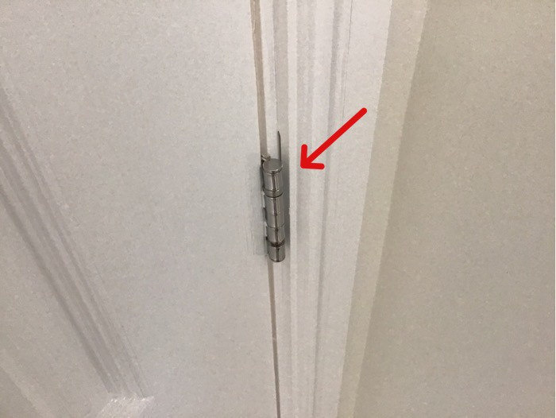
Location 26 Hall
Assigned To Joiner
The latch is preventing the fire door to close on the garage door.
Location 27 General
Assigned To Joiner
Insufficient fixings in the door handles.
Location 28 General
Assigned To Decorator
The architrave needs caulking behind the hinges.

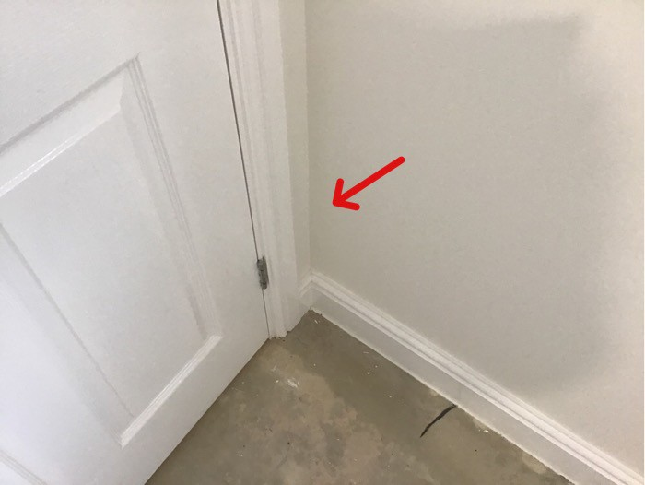
Location 29 Study
Assigned To Decorator
The wall needs sanding and filling.
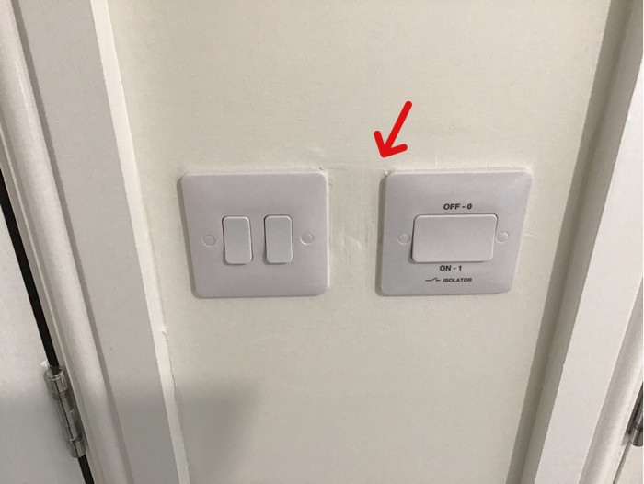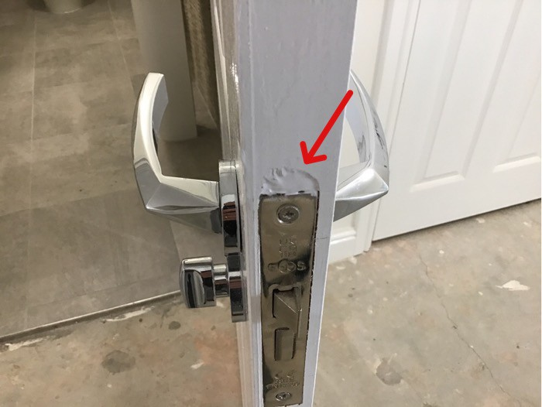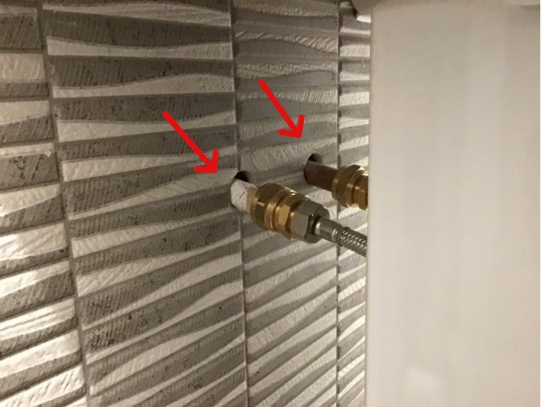
Location 30 Hall
Assigned To Decorator
The wall needs filling between the switches.
Location 31 Downstairs Cloaks
Assigned To Decorator
The door edge needs filling.
Location 32 Downstairs Cloaks
Assigned To Wall Tiller
The sink pipes need grouting.

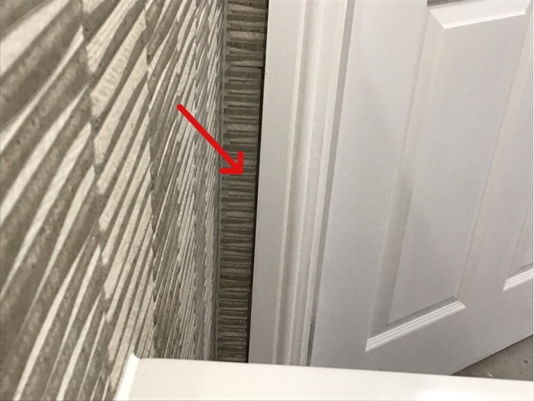
Location 33 Downstairs Cloaks
Assigned To Wall Tiller
The tiles and architrave need sealing.
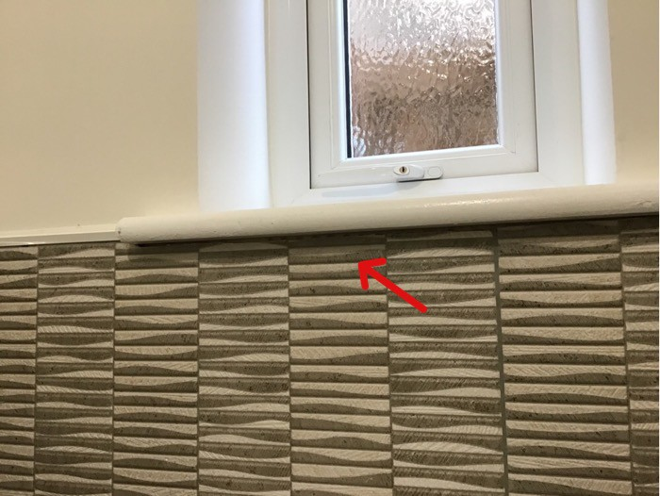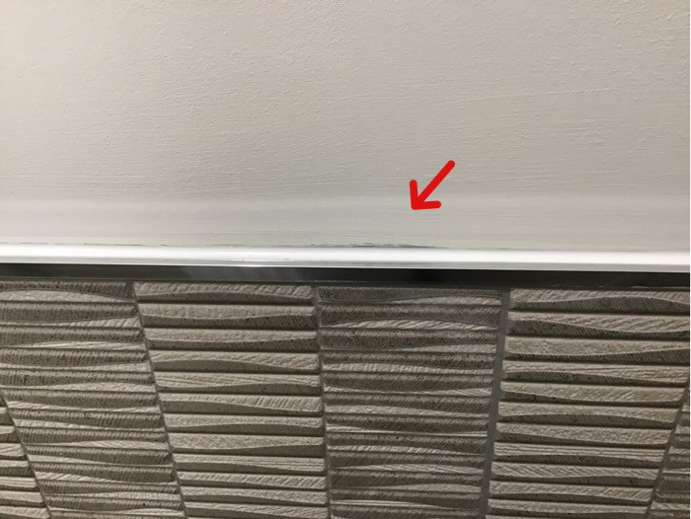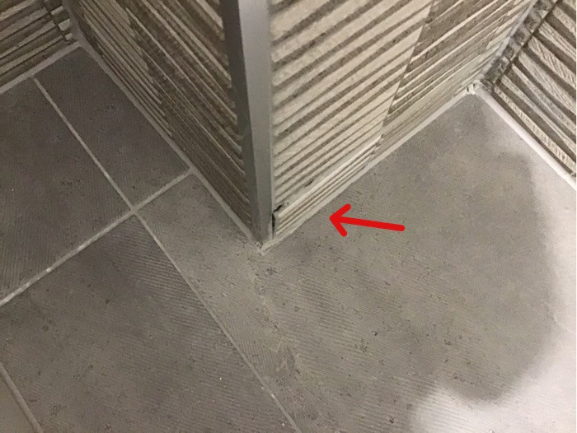
Location 34 Downstairs Cloaks
Assigned To Wall Tiller
Underneath the window board needs grouting.
Location 35 Downstairs Cloaks
Assigned To Decorator
The wall needs touching up above the tile trim.
Location 36 Downstairs Cloaks
Assigned To Wall Tiller
The tile needs refitting on the boxing in.

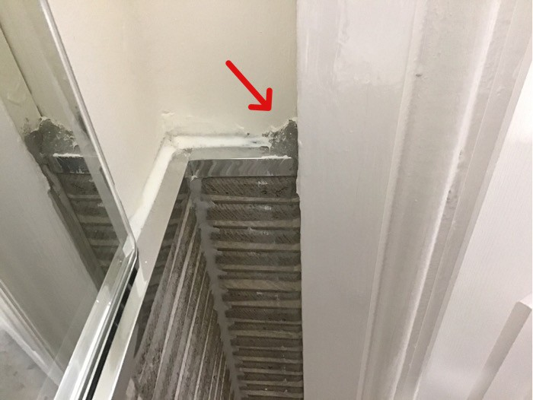
Location 37 Downstairs Cloaks
Assigned To Wall Tiller
The grout needs removing from the tile trim.
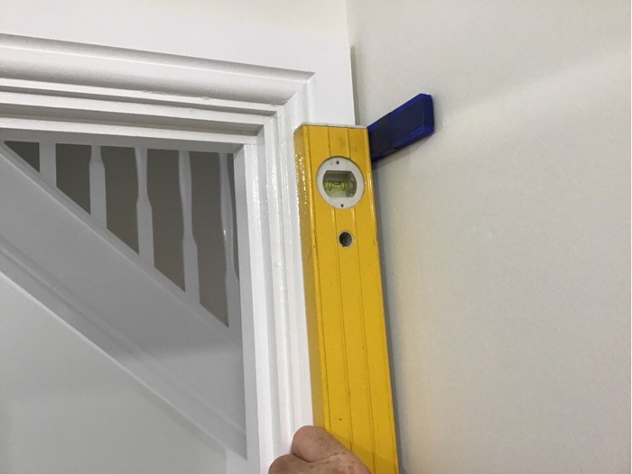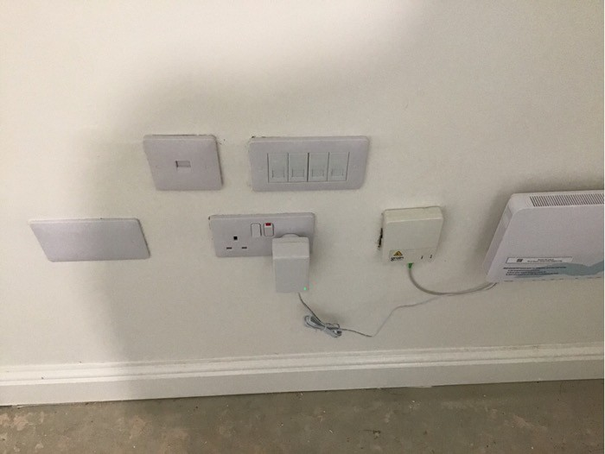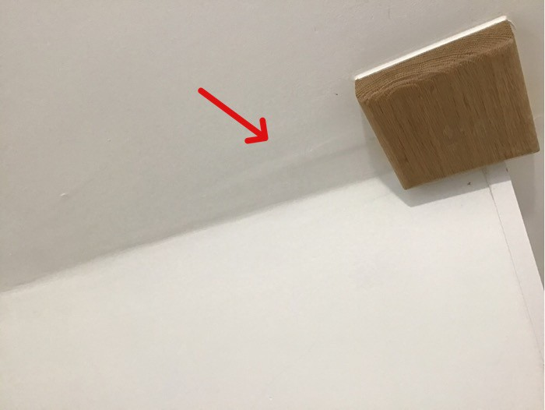
Location 38 Downstairs Cloaks
Assigned To Joiner The wall is not plumb.
NHBC Standards Chapter 9.1.3
Location 39 Hall Cupboard
Assigned To Decorator / Electrician
The sockets need levelling and the wall filling.
Location 40 Hall
Assigned To Decorator The ceiling needs filling.

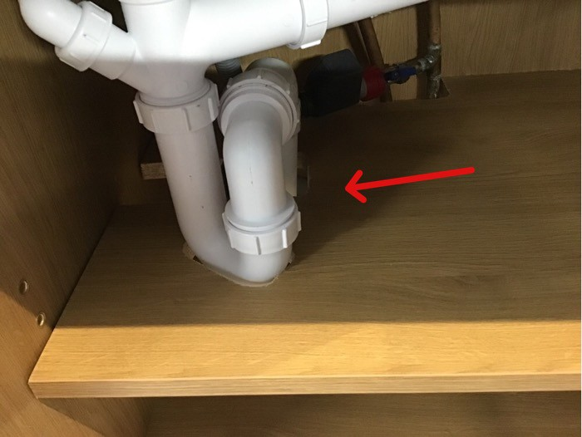
Location 41 Kitchen
Assigned To Joiner
The cut out in the sink base shelf needs sealing to prevent it from blowing if the trap leaks.
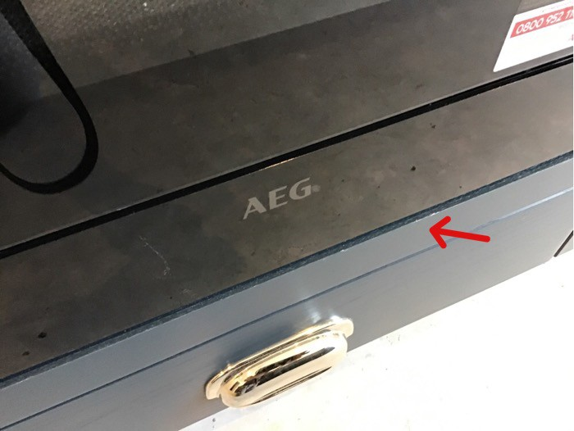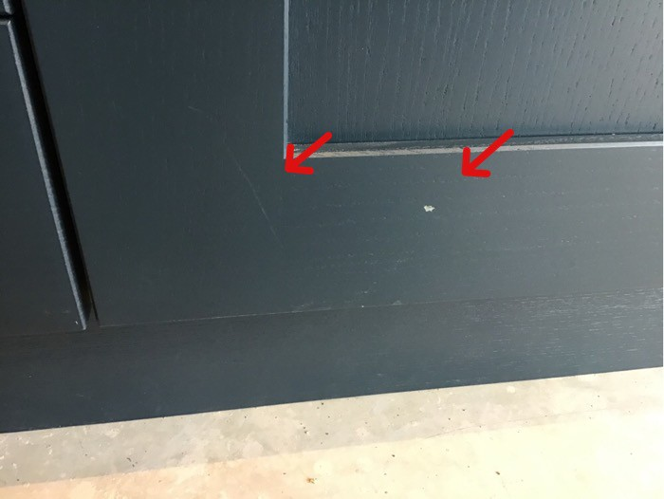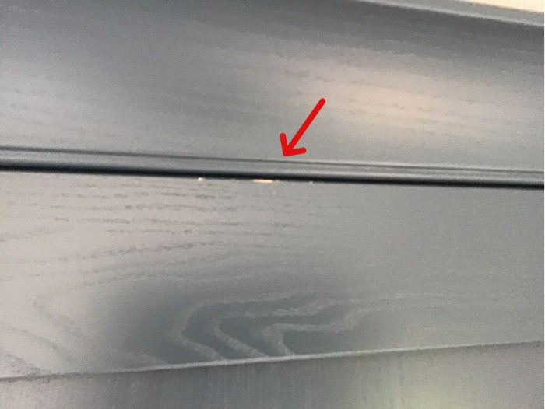
Location 42 Kitchen
Assigned To Plastic Surgeon
The infill underneath the microwave is marked.
Location 43 Kitchen
Assigned To Plastic Surgeon
The bottom drawer to the right of the microwave is scratched and chipped.
Location 44 Kitchen
Assigned To Plastic Surgeon
The top of the tall housing door is marked.

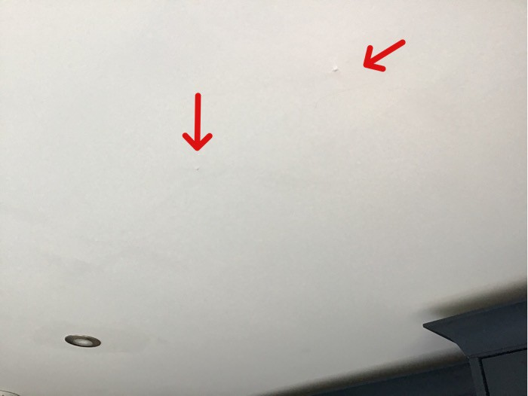
Location 45 Kitchen
Assigned To Decorator/ Plasterer
The ceiling needs sanding and filling in several areas.
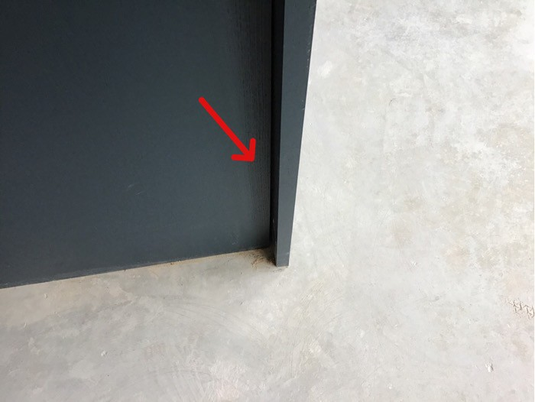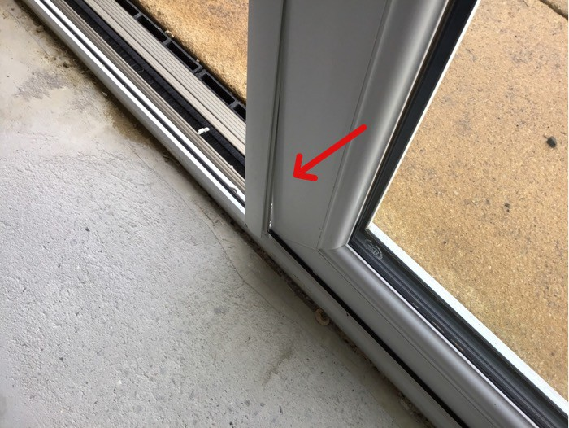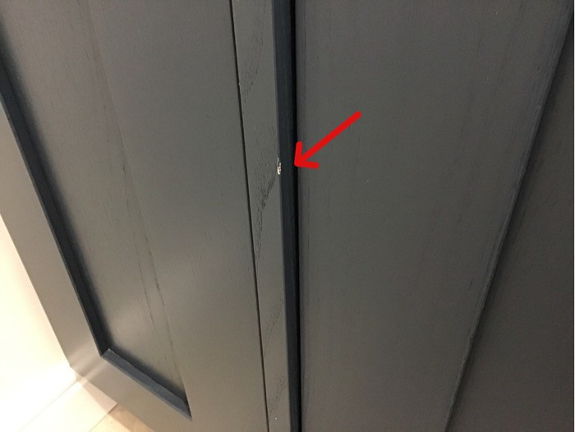
Location 46 Kitchen
Assigned To Kitchen Fitter
The island unit end panels are not tight against the back board.
Location 47 Kitchen
Assigned To Window Fitter
The strip needs refitting to the bifold door.
Location 48 Utility
Assigned To Plastic Surgeon The tall housing is chipped.

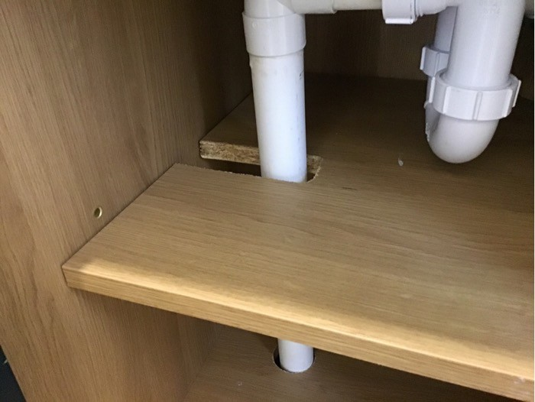
Location 49 Utility
Assigned To Joiner
The cut out in the sink base unit shelf needs sealing to prevent it from blowing if the trap leaks.
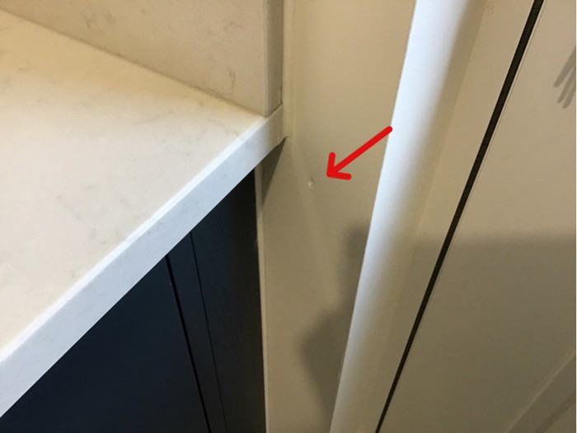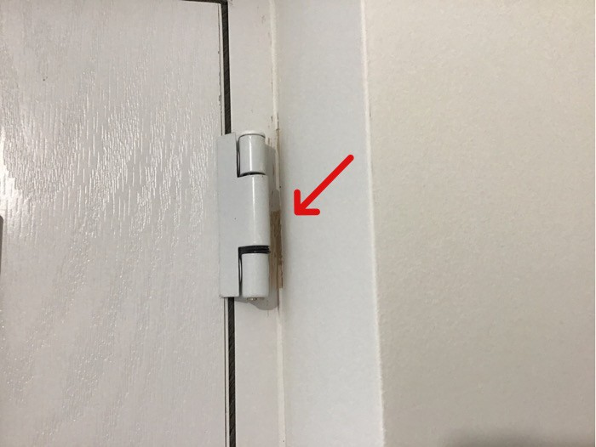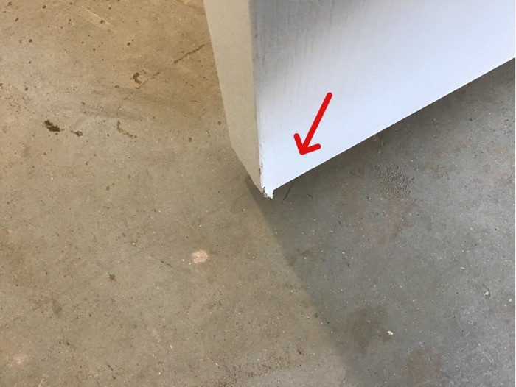
Location 50 Utility
Assigned To Decorator The wall needs filling.
Location 51 Utility
Assigned To Cleaner
The door frame needs cleaning behind the hinges.
Location 52 Kitchen
Assigned To Decorator
The bottom of the door is damaged.

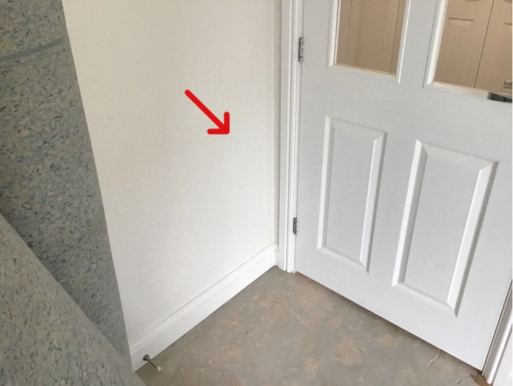
Location 53 Lounge
Assigned To Decorator The wall needs painting.
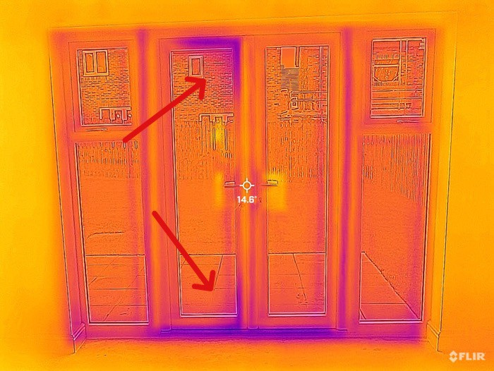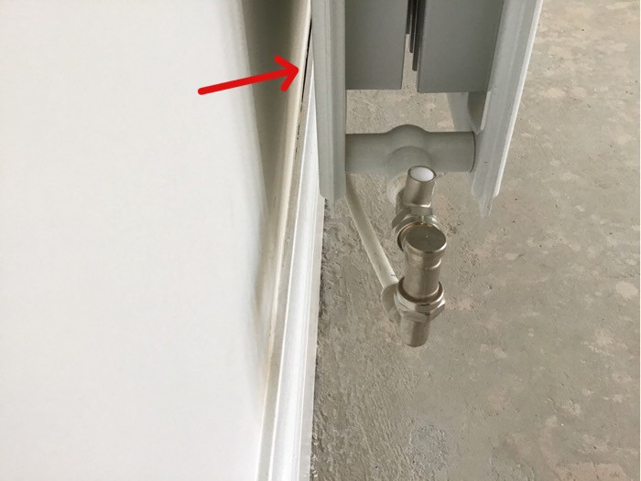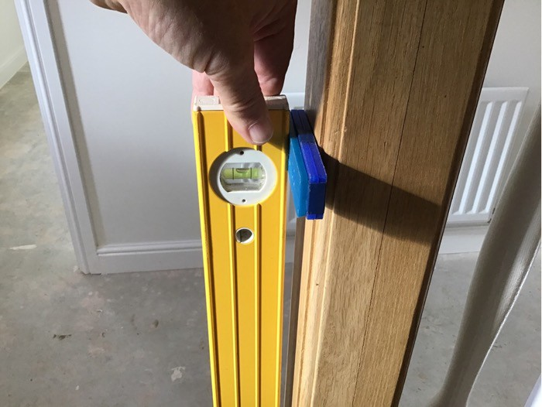
Location 54 Lounge
Assigned To Window Fitter
The patio doors need tightening on the seals to prevent cold air ingress.
Location 55 Lounge
Assigned To Decorator
The skirting board needs caulking behind the radiator.
Location 56 Stairs To First Floor
Assigned To Joiner
The bottom newel is not plumb.
NHBC Standards Chapter 6.6.12

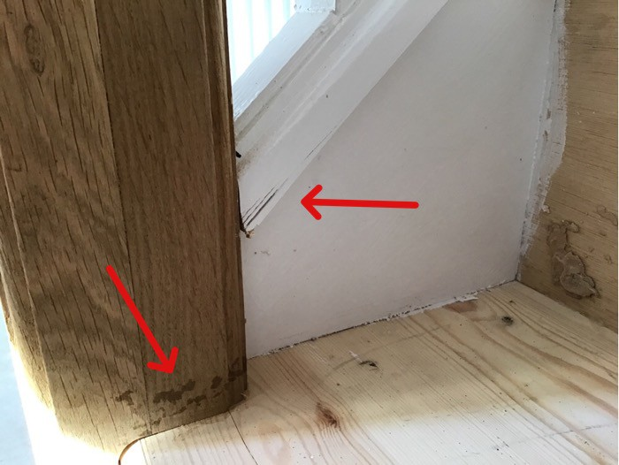
Location 57 Stairs To First Floor
Assigned To Decorator
The bottom of the banister is damaged and the staining needs removing from the newel post.
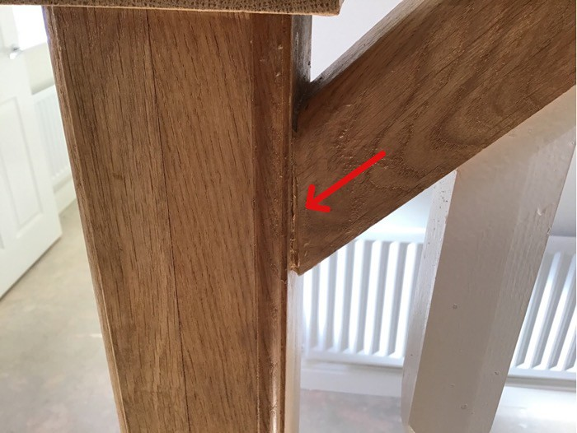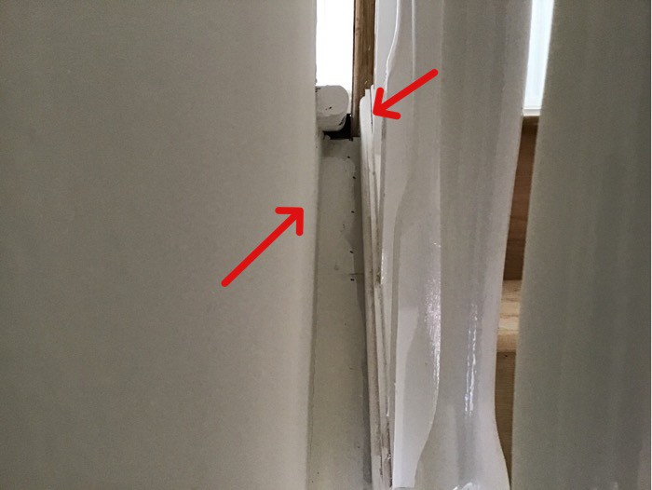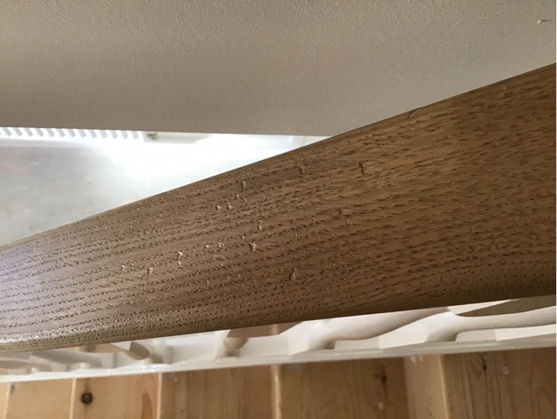
Location 58 Stairs To First Floor
Assigned To Joiner
The handrail has been poorly cut.
Location 59 Stairs To First Floor
Assigned To Decorator
The infill needs filling and painting.
Location 60 Stairs To First Floor
Assigned To Plastic Surgeon
The top of the handrail is poorly finished.

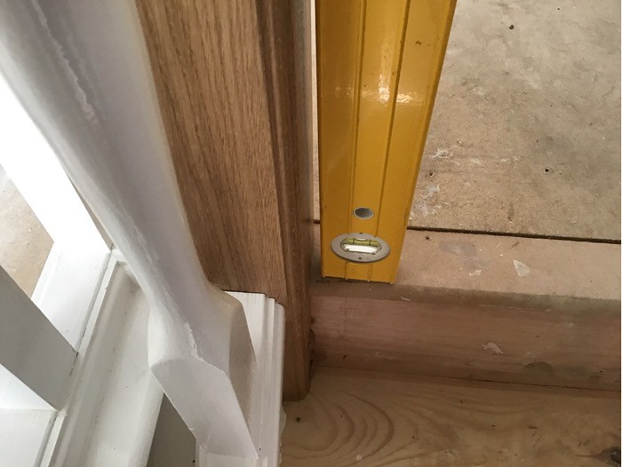
Location 61 Stairs To First Floor
Assigned To Joiner
The top newel is not plumb.
NHBC Standards Chapter 6.6.12
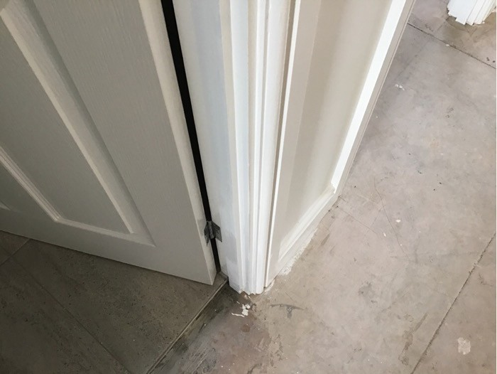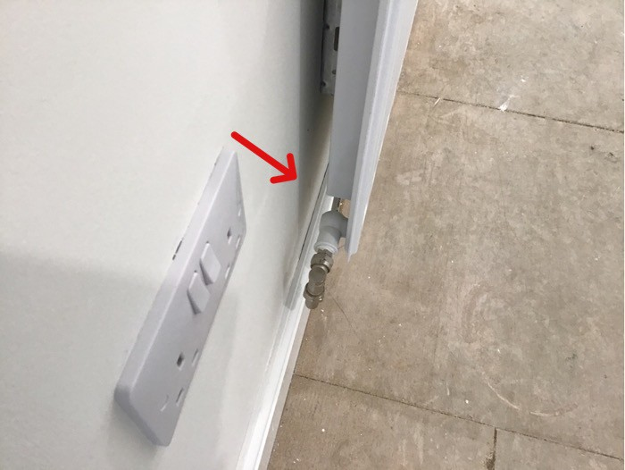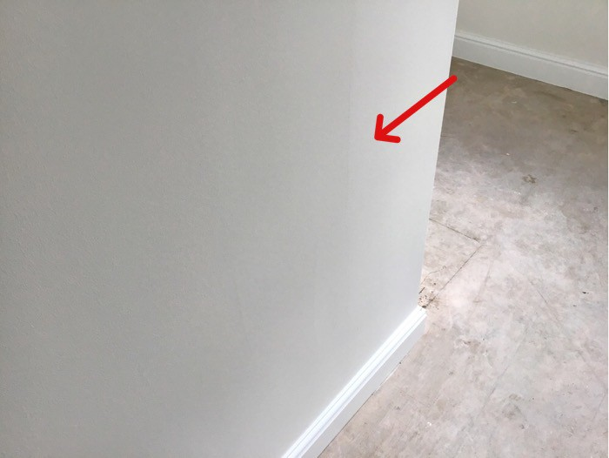
Location 62 Landing
Assigned To Decorator
The bathroom casing needs filling and the bead glossing.
Location 63 Landing
Assigned To Decorator
The skirting board needs caulking behind the radiator.
Location 64 Bedroom 4
Assigned To Decorator
The trowel marks need sanding.

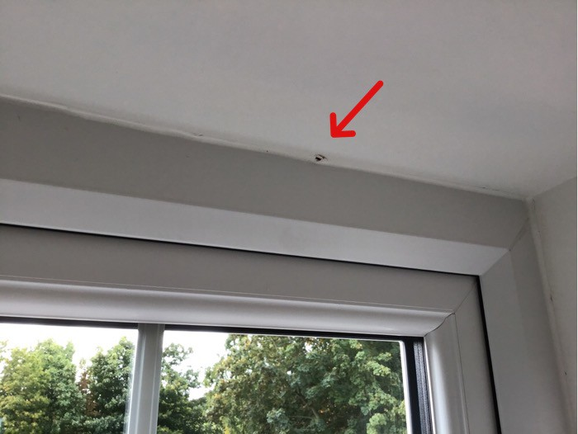
Location 65 Bedroom 4
Assigned To Mastic
The sealant needs reapplying to the window frame.
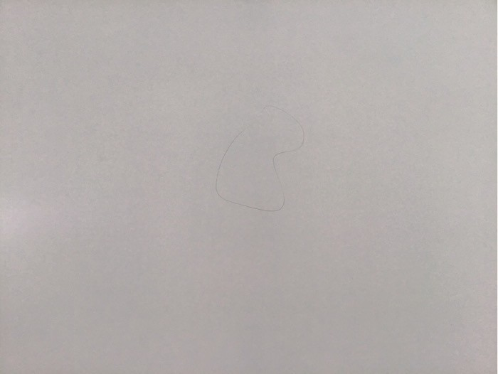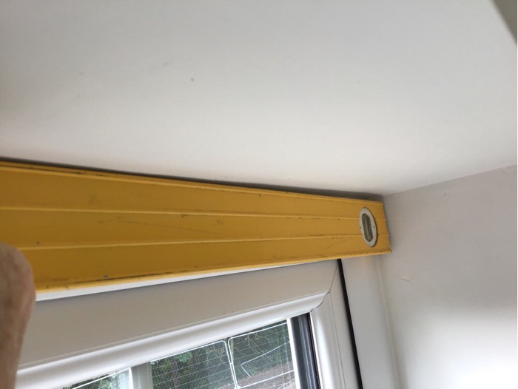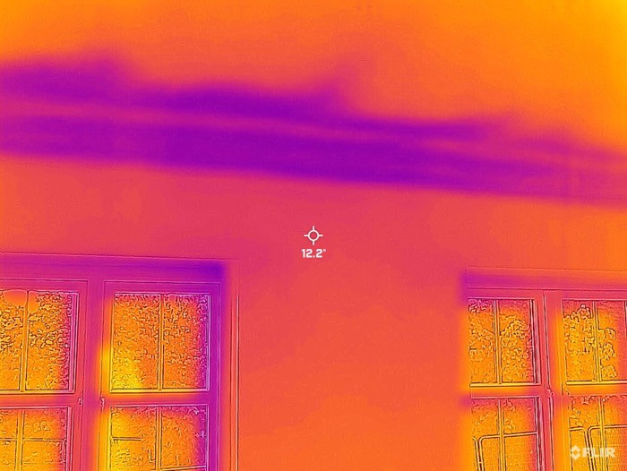
Location 66 Bedroom 4
Assigned To Decorator
The wall needs touching up between the windows.
Location 67 Bedroom 4
Assigned To Plasterer
The right hand window head is out of tolerance.
NHBC Standards Chapter 9.1.4
Location 68 Bedroom 4
Assigned To Insulation
The insulation needs adjusting to prevent heat loss.

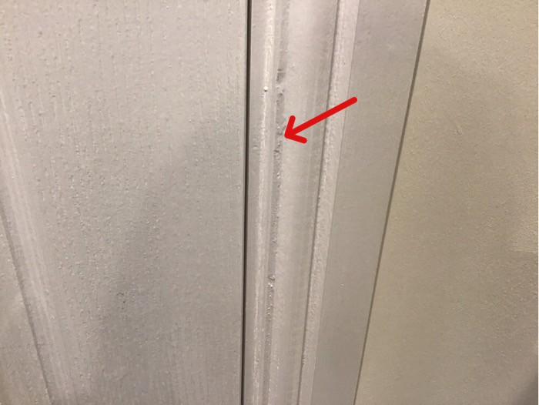
Location 69 Bathroom
Assigned To Decorator
The architraves needs sanding.
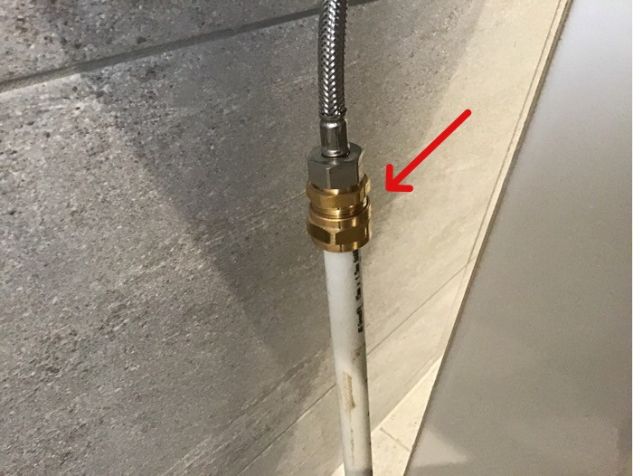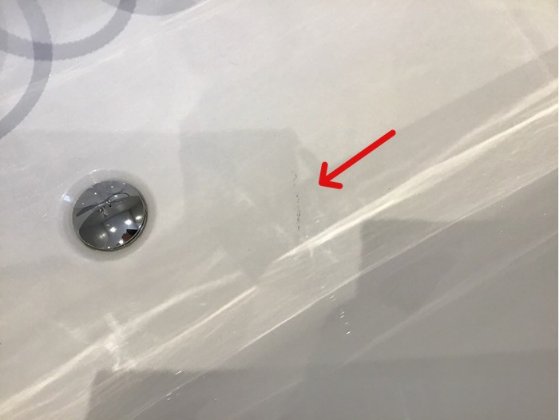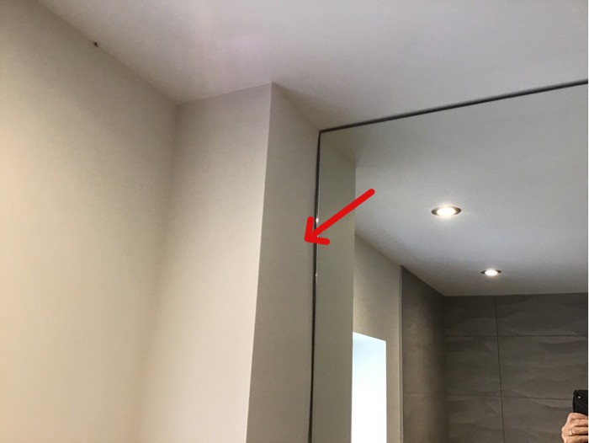
Location 70 Note
Assigned To Plumber
No none return valves fitted to the sink pipes?
Location 71 Bathroom
Assigned To Plastic Surgeon The bath is marked.
Location 72 Bathroom
Assigned To Plasterer
The pipe boxing needs filling out, showing on the mirror.

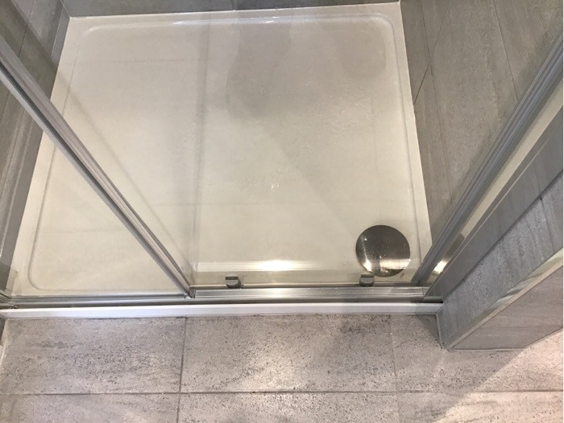
Location 73 Bathroom
Assigned To Plastic Surgeon The shower tray is scratched.
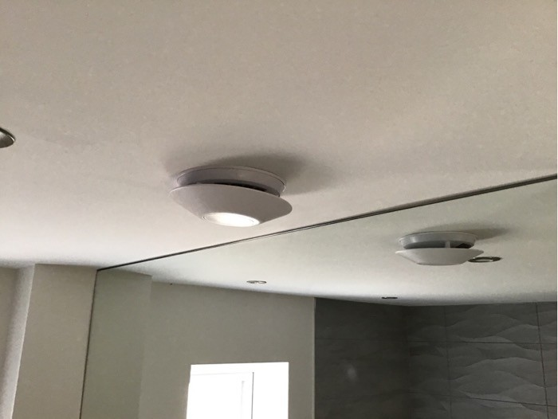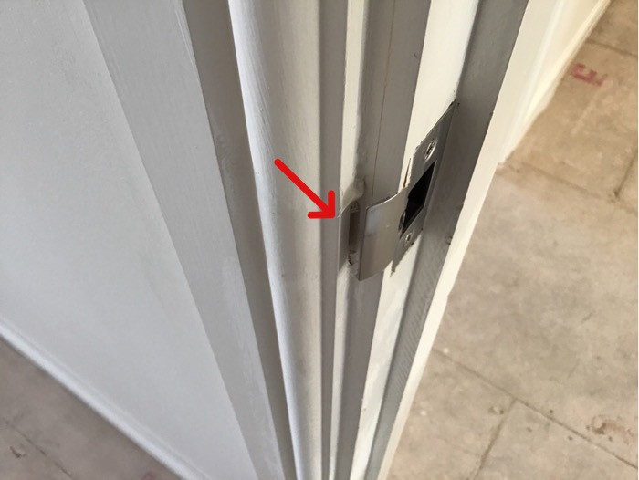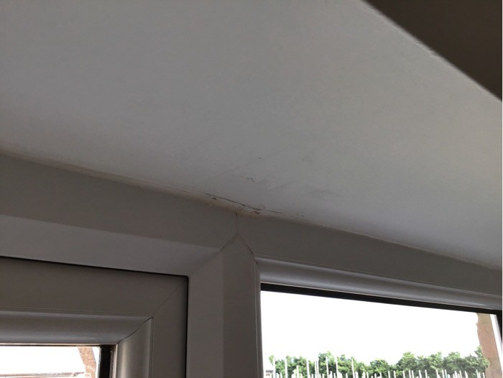
Location 74 Bathroom
Assigned To Electrician
The extractor cover needs refitting.
Location 75 Bedroom 3
Assigned To Decorator
The casing needs caulking and filling.
Location 76 Bedroom 3
Assigned To Decorator
The window head needs sanding.

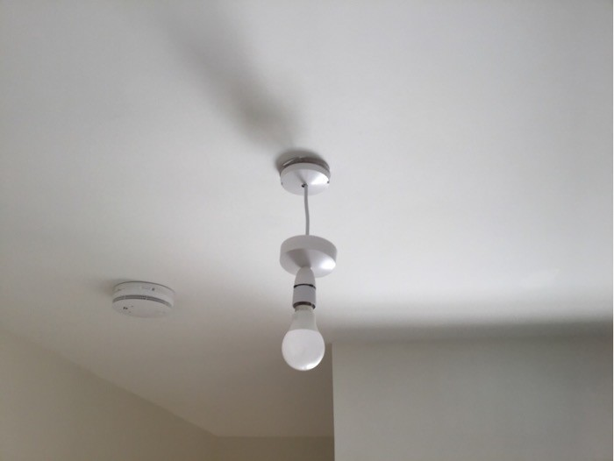
Location 77 General
Assigned To Electrician
The light pendant covers need fitting.
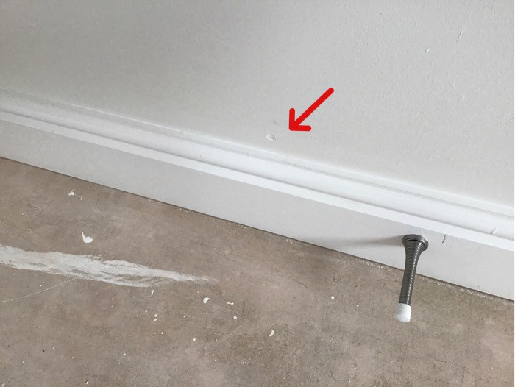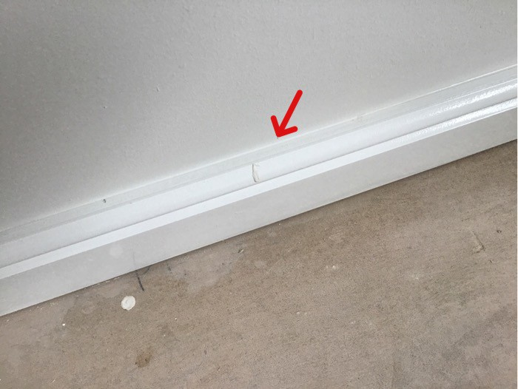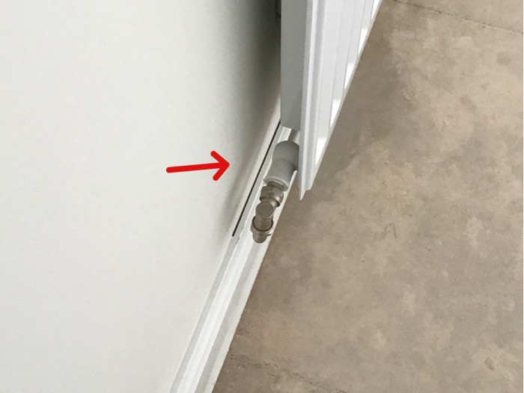
Location 78 Bedroom 5
Assigned To Decorator The wall needs filling.
Location 79 Bedroom 5
Assigned To Decorator
The paint run needs sanding on the skirting board.
Location 80 Bedroom 5
Assigned To Decorator
The skirting board needs caulking behind the radiator.

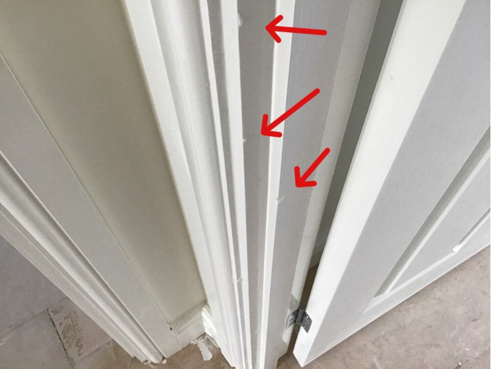
Location 81 Bedroom 5
Assigned To Decorator
The door stop bead needs filling.
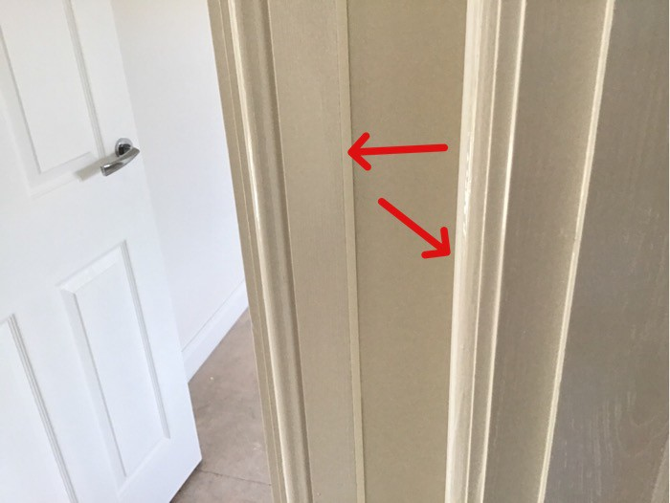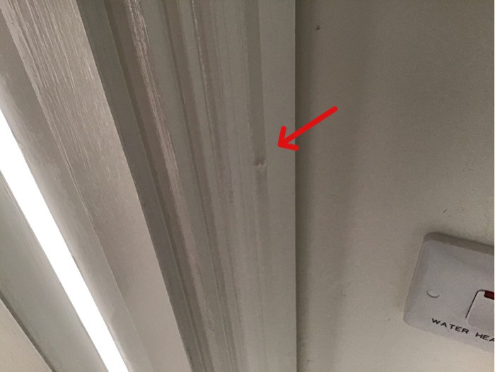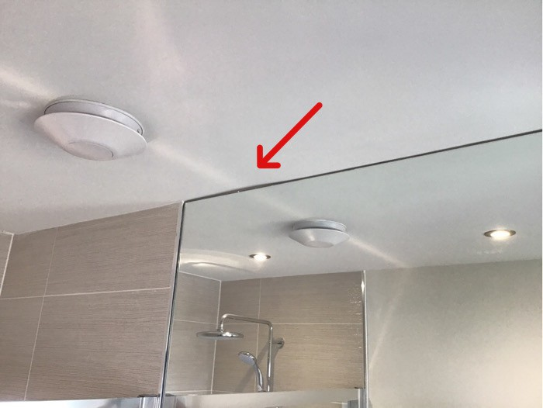
Location 82 Landing
Assigned To Decorator
Bedroom 3 & 5 architrave edges need painting.
Location 83 Cylinder Cupboard
Assigned To Joiner
The pin needs punching in the architrave.
Location 84 En Suite
Assigned To Plasterer The ceiling is running out

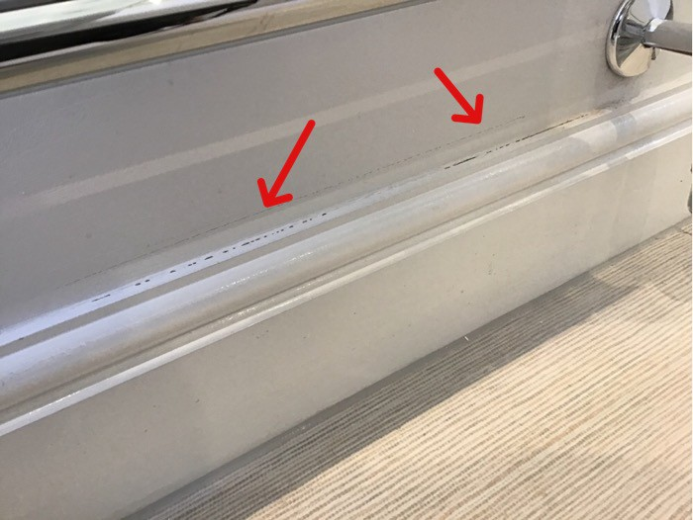
Location 85 En Suite
Assigned To Decorator
The top of the skirting board needs caulking.
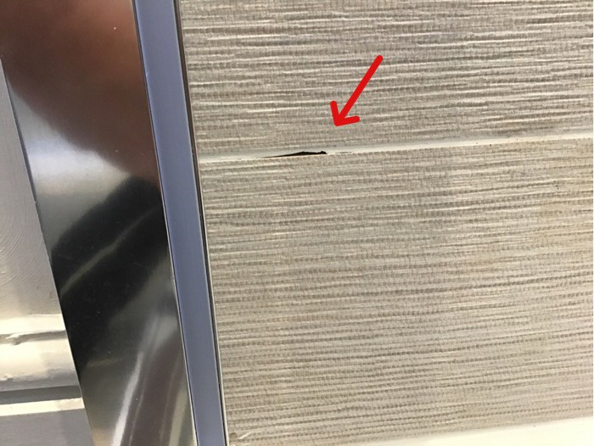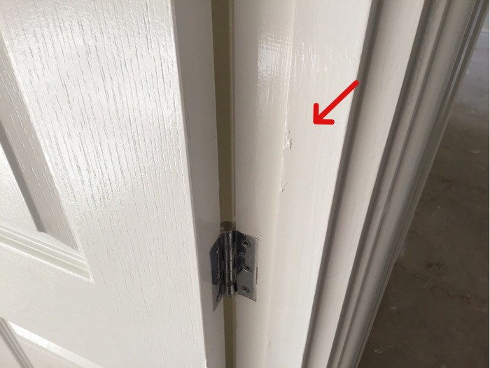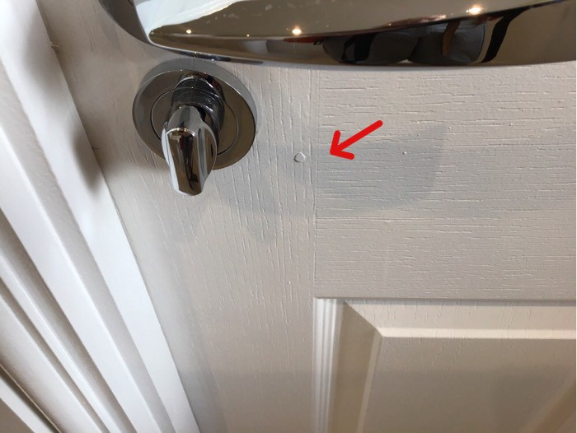
Location 86 En Suite
Assigned To Wall Tiller
The pin holes in the shower need grouting.
Location 87 Bedroom 1
Assigned To Decorator
The door stop bead needs sanding.
Location 88 En Suite
Assigned To Decorator The door needs sanding.

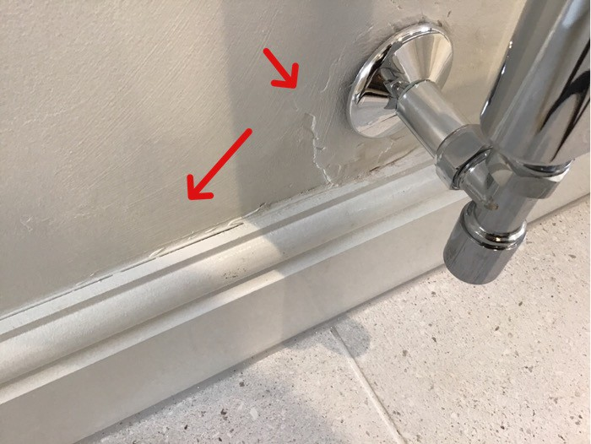
Location 89 En Suite
Assigned To Decorator
The wall needs sanding around the radiator pipes and the skirting board needs caulking.
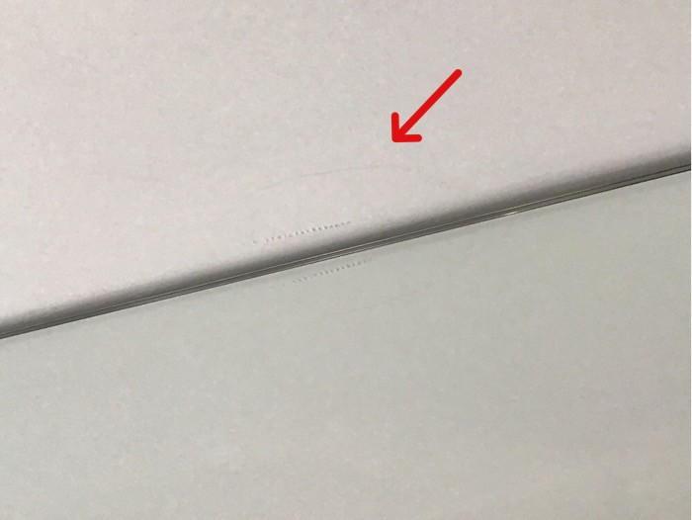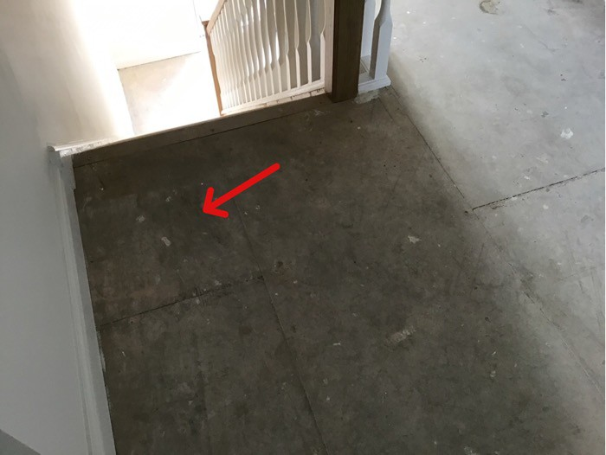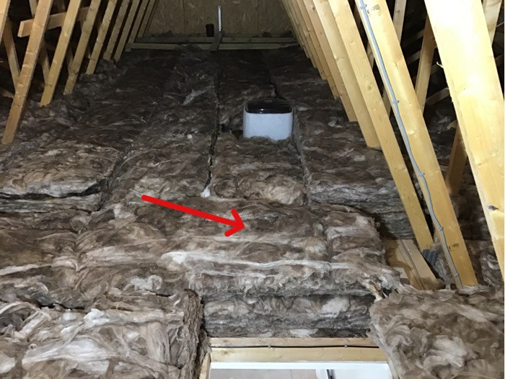
Location 90 En Suite
Assigned To Decorator
The ceiling needs sanding and touching up.
Location 91 Landing
Assigned To Joiner The floor is squeaking.
Location 92 Roof
Assigned To Joiner
No walkway to maintain the extractor.
NHBC Standards Chapter 8.3.6

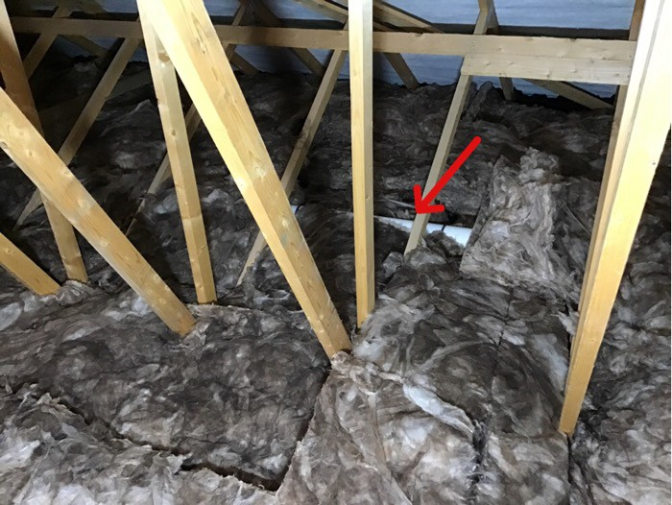
Location 93 Roof
Assigned To Labourer
The extractor duct needs insulating.
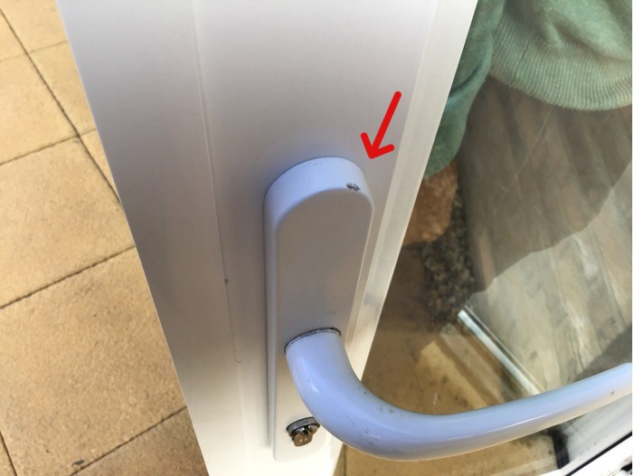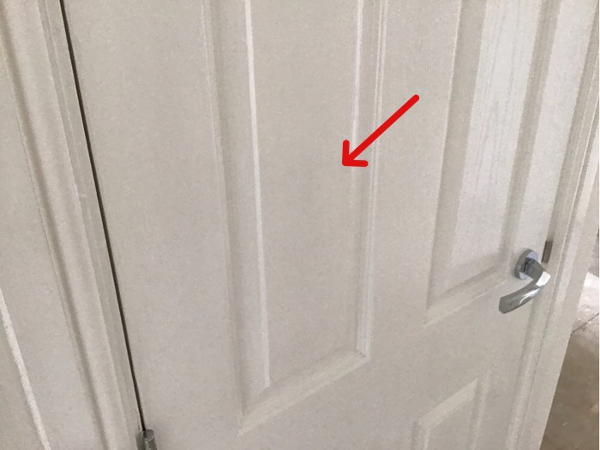
Location 94 Rear Elevation
Assigned To Window Fitter
The bifold door handle is chipped.
Location 95 Landing
Assigned To Decorator
The cylinder cupboard door needs touching up

